What is Web Service

A **Web Service** is can be defined by following ways:

* is a client server application or application component for communication.
* method of communication between two devices over network.
* is a software system for interoperable machine to machine communication.
* is a collection of standards or protocols for exchanging information between two devices or application.

Let's understand it by the figure given below:

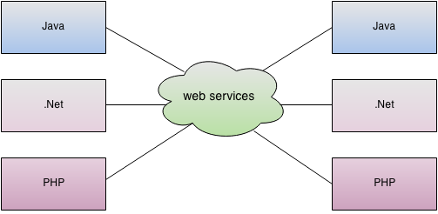

As you can see in the figure, java, .net or PHP applications can communicate with other applications through web service over the network. For example, java application can interact with Java, .Net and PHP applications. So web service is a language independent way of communication.

Types of Web Services

There are mainly two types of web services.

1. SOAP web services.
2. RESTful web services.

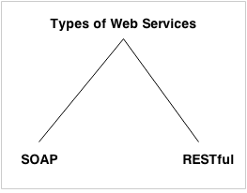

Web Service Components

There are three major web service components.

1. SOAP
2. WSDL
3. UDDI

SOAP

SOAP is an acronym for Simple Object Access Protocol.

SOAP is a XML-based protocol for accessing web services.

SOAP is a W3C recommendation for communication between applications.

SOAP is XML based, so it is platform independent and language independent. In other words, it can be used with Java, .Net or PHP language on any platform.

WSDL

WSDL is an acronym for Web Services Description Language.

WSDL is a xml document containing information about web services such as method name, method parameter and how to access it.

WSDL is a part of UDDI. It acts as a interface between web service applications.

WSDL is pronounced as wiz-dull.

UDDI

UDDI is an acronym for Universal Description, Discovery and Integration.

UDDI is a XML based framework for describing, discovering and integrating web services.

UDDI is a directory of web service interfaces described by WSDL, containing information about web services.

# SOAP Web Services

SOAP stands for Simple Object Access Protocol. It is a XML-based protocol for accessing web services.

SOAP is a W3C recommendation for communication between two applications.

SOAP is XML based protocol. It is platform independent and language independent. By using SOAP, you will be able to interact with other programming language applications.

## Advantages of Soap Web Services

**WS Security**: SOAP defines its own security known as WS Security.

**Language and Platform independent**: SOAP web services can be written in any programming language and executed in any platform.

## Disadvantages of Soap Web Services

**Slow**: SOAP uses XML format that must be parsed to be read. It defines many standards that must be followed while developing the SOAP applications. So it is slow and consumes more bandwidth and resource.

**WSDL dependent**: SOAP uses WSDL and doesn't have any other mechanism to discover the service.

# RESTful Web Services

REST stands for REpresentational State Transfer.

REST is an architectural style not a protocol.

## Advantages of RESTful Web Services

**Fast**: RESTful Web Services are fast because there is no strict specification like SOAP. It consumes less bandwidth and resource.

**Language and Platform independent**: RESTful web services can be written in any programming language and executed in any platform.

**Can use SOAP**: RESTful web services can use SOAP web services as the implementation.

**Permits different data format**: RESTful web service permits different data format such as Plain Text, HTML, XML and JSON.

# SOAP vs REST Web Services

There are many differences between SOAP and REST web services. The important 10 differences between SOAP and REST are given below:

|  |  |  |
| --- | --- | --- |
| **No.** | **SOAP** | **REST** |
| 1) | SOAP is a **protocol**. | REST is an **architectural style**. |
| 2) | SOAP stands for **Simple Object Access Protocol**. | REST stands for **REpresentational State Transfer**. |
| 3) | SOAP **can't use REST** because it is a protocol. | REST **can use SOAP** web services because it is a concept and can use any protocol like HTTP, SOAP. |
| 4) | SOAP **uses services interfaces to expose the business logic**. | REST **uses URI to expose business logic**. |
| 5) | **JAX-WS** is the java API for SOAP web services. | **JAX-RS** is the java API for RESTful web services. |
| 6) | SOAP **defines standards**to be strictly followed. | REST does not define too much standards like SOAP. |
| 7) | SOAP **requires more bandwidth** and resource than REST. | REST **requires less bandwidth** and resource than SOAP. |
| 8) | SOAP **defines its own security**. | RESTful web services **inherits security measures** from the underlying transport. |
| 9) | SOAP **permits XML** data format only. | REST **permits different** data format such as Plain text, HTML, XML, JSON etc. |
| 10) | SOAP is **less preferred** than REST. | REST **more preferred** than SOAP. |

# Service Oriented Architecture (SOA)

Service Oriented Architecture or SOA is a design pattern. It is designed to provide services to other applications through protocol. It is a concept only and not tied to any programming language or platform.

Web services is a technology of SOA most likely.

## Service

A service is well-defined, self-contained function that represents unit of functionality. A service can exchange information from another service. It is not dependent on the state of another service.

## Service Connections

The figure given below illustrates the service oriented architecture. Service consumer sends service request to the service provider and service provider sends the service response to the service consumer. The service connection is understandable to both service consumer and service provider.

JAX-WS Tutorial

**JAX-WS tutorial** is provides concepts and examples of JAX-WS API. This JAX-WS tutorial is designed for beginners and professionals.

There are two ways to develop JAX-WS example.

1. RPC style
2. Document style

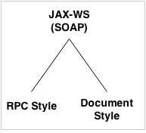

JAX-WS Example RPC Style

Creating JAX-WS example is a easy task because it requires no extra configuration settings.

JAX-WS API is inbuilt in JDK, so you don't need to load any extra jar file for it. Let's see a simple example of JAX-WS example in RPC style.

There are created 4 files for hello world JAX-WS example:

1. HelloWorld.java
2. HelloWorldImpl.java
3. Publisher.java
4. HelloWorldClient.java

The first 3 files are created for server side and 1 application for client side.

JAX-WS Server Code

*File: HelloWorld.java*

1. **package** com.javatpoint;
2. **import** javax.jws.WebMethod;
3. **import** javax.jws.WebService;
4. **import** javax.jws.soap.SOAPBinding;
5. **import** javax.jws.soap.SOAPBinding.Style;
6. //Service Endpoint Interface
7. @WebService
8. @SOAPBinding(style = Style.RPC)
9. **public** **interface** HelloWorld{
10. @WebMethod String getHelloWorldAsString(String name);
11. }

*File: HelloWorldImpl.java*

1. **package** com.javatpoint;
2. **import** javax.jws.WebService;
3. //Service Implementation
4. @WebService(endpointInterface = "com.javatpoint.HelloWorld")
5. **public** **class** HelloWorldImpl **implements** HelloWorld{
6. @Override
7. **public** String getHelloWorldAsString(String name) {
8. **return** "Hello World JAX-WS " + name;
9. }
10. }

*File: Publisher.java*

1. **package** com.javatpoint;
2. **import** javax.xml.ws.Endpoint;
3. //Endpoint publisher
4. **public** **class** HelloWorldPublisher{
5. **public** **static** **void** main(String[] args) {
6. Endpoint.publish("http://localhost:7779/ws/hello", **new** HelloWorldImpl());
7. }
8. }

How to view generated WSDL

After running the publisher code, you can see the generated WSDL file by visiting the URL:

1. http://localhost:7779/ws/hello?wsdl

JAX-WS Client Code

*File: HelloWorldClient.java*

1. **package** com.javatpoint;
2. **import** java.net.URL;
3. **import** javax.xml.namespace.QName;
4. **import** javax.xml.ws.Service;
5. **public** **class** HelloWorldClient{
6. **public** **static** **void** main(String[] args) **throws** Exception {
7. URL url = **new** URL("http://localhost:7779/ws/hello?wsdl");
9. //1st argument service URI, refer to wsdl document above
10. //2nd argument is service name, refer to wsdl document above
11. QName qname = **new** QName("http://javatpoint.com/", "HelloWorldImplService");
12. Service service = Service.create(url, qname);
13. HelloWorld hello = service.getPort(HelloWorld.**class**);
14. System.out.println(hello.getHelloWorldAsString("javatpoint rpc"));
15. }
16. }

Output:

Hello World JAX-WS javatpoint rpc

JAX-RS Tutorial

**JAX-RS tutorial** is provides concepts and examples of JAX-RS API. This JAX-RS tutorial is designed for beginners and professionals.

There are two main implementation of JAX-RS API.

1. Jersey
2. RESTEasy

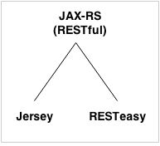

AX-RS Example Jersey

We can create JAX-RS example by jersey implementation. To do so, you need to load jersey jar files or use maven framework.

In this example, we are using jersey jar files for using jersey example for JAX-RS.

[Click me to download jersey jar files.](https://www.javatpoint.com/webservicepages/download/jerseyjars.zip)

There are created 4 files for hello world JAX-RS example:

1. Hello.java
2. web.xml
3. index.html
4. HelloWorldClient.java

The first 3 files are created for server side and 1 application for client side.

JAX-RS Server Code

*File: Hello.java*

1. **package** com.javatpoint.rest;
2. **import** javax.ws.rs.GET;
3. **import** javax.ws.rs.Path;
4. **import** javax.ws.rs.Produces;
5. **import** javax.ws.rs.core.MediaType;
6. @Path("/hello")
7. **public** **class** Hello {
8. // This method is called if HTML and XML is not requested
9. @GET
10. @Produces(MediaType.TEXT_PLAIN)
11. **public** String sayPlainTextHello() {
12. **return** "Hello Jersey Plain";
13. }
14. // This method is called if XML is requested
15. @GET
16. @Produces(MediaType.TEXT_XML)
17. **public** String sayXMLHello() {
18. **return** "<?xml version=\"1.0\"?>" + "<hello> Hello Jersey" + "</hello>";
19. }
21. // This method is called if HTML is requested
22. @GET
23. @Produces(MediaType.TEXT_HTML)
24. **public** String sayHtmlHello() {
25. **return** "<html> " + "<title>" + "Hello Jersey" + "</title>"
26. + "<body><h1>" + "Hello Jersey HTML" + "</h1></body>" + "</html> ";
27. }
28. }

*File: web.xml*

1. **<?xml** version="1.0" encoding="UTF-8"**?>**
2. **<web-app** xmlns:xsi="http://www.w3.org/2001/XMLSchema-instance"
3. xmlns="http://java.sun.com/xml/ns/javaee"
4. xsi:schemaLocation="http://java.sun.com/xml/ns/javaee
5. http://java.sun.com/xml/ns/javaee/web-app_3_0.xsd"
6. id="WebApp_ID" version="3.0"**>**
7. **<servlet>**
8. **<servlet-name>**Jersey REST Service**</servlet-name>**
9. **<servlet-class>**org.glassfish.jersey.servlet.ServletContainer**</servlet-class>**
10. **<init-param>**
11. **<param-name>**jersey.config.server.provider.packages**</param-name>**
12. **<param-value>**com.javatpoint.rest**</param-value>**
13. **</init-param>**
14. **<load-on-startup>**1**</load-on-startup>**
15. **</servlet>**
16. **<servlet-mapping>**
17. **<servlet-name>**Jersey REST Service**</servlet-name>**
18. **<url-pattern>**/rest/\***</url-pattern>**
19. **</servlet-mapping>**
20. **</web-app>**

*File: index.html*

1. **<a** href="rest/hello"**>**Click Here**</a>**

Now run this application on server. Here we are using Tomcat server on port 4444. The project name is restfuljersey.

After running the project, you will see the following output:

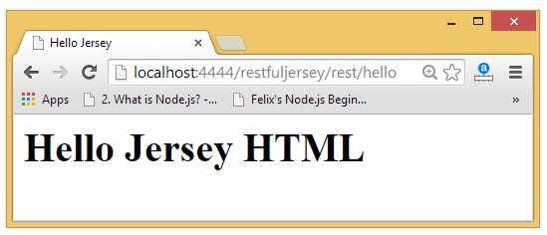

JAX-RS Client Code

The ClientTest.java file is created inside the server application. But you can run client code by other application also by having service interface and jersey jar file.

*File: ClientTest.java*

1. **package** com.javatpoint.restclient;
2. **import** java.net.URI;
3. **import** javax.ws.rs.client.Client;
4. **import** javax.ws.rs.client.ClientBuilder;
5. **import** javax.ws.rs.client.WebTarget;
6. **import** javax.ws.rs.core.MediaType;
7. **import** javax.ws.rs.core.UriBuilder;
8. **import** org.glassfish.jersey.client.ClientConfig;
9. **public** **class** ClientTest {
10. **public** **static** **void** main(String[] args) {
11. ClientConfig config = **new** ClientConfig();
12. Client client = ClientBuilder.newClient(config);
13. WebTarget target = client.target(getBaseURI());
14. //Now printing the server code of different media type
15. System.out.println(target.path("rest").path("hello").request().accept(MediaType.TEXT_PLAIN).get(String.**class**));
16. System.out.println(target.path("rest").path("hello").request().accept(MediaType.TEXT_XML).get(String.**class**));
17. System.out.println(target.path("rest").path("hello").request().accept(MediaType.TEXT_HTML).get(String.**class**));
18. }
19. **private** **static** URI getBaseURI() {
20. //here server is running on 4444 port number and project name is restfuljersey
21. **return** UriBuilder.fromUri("http://localhost:4444/restfuljersey").build();
22. }
23. }

Output:

Hello Jersey Plain

<?xml version="1.0"?><hello> Hello Jersey</hello>

<html> <title>Hello Jersey</title><body><h1>Hello Jersey HTML</h1></body></html>

RESTful JAX-RS Annotations Example

JAX-RS API provides following annotations to develop RESTful applications in java. We are using jersey implementation for developing JAX-RS examples.

[Click me to download jersey jar files.](https://www.javatpoint.com/webservicepages/download/jerseyjars.zip)

JAX-RS Annotations

The **javax.ws.rs** package contains JAX-RS annotations.

|  |  |
| --- | --- |
| **Annotation** | **Description** |
| Path | It identifies the URI path. It can be specified on class or method. |
| PathParam | represents the parameter of the URI path. |
| GET | specifies method responds to GET request. |
| POST | specifies method responds to POST request. |
| PUT | specifies method responds to PUT request. |
| HEAD | specifies method responds to HEAD request. |
| DELETE | specifies method responds to DELETE request. |
| OPTIONS | specifies method responds to OPTIONS request. |
| FormParam | represents the parameter of the form. |
| QueryParam | represents the parameter of the query string of an URL. |
| HeaderParam | represents the parameter of the header. |
| CookieParam | represents the parameter of the cookie. |
| Produces | defines media type for the response such as XML, PLAIN, JSON etc. It defines the media type that the methods of a resource class or MessageBodyWriter can produce. |
| Consumes | It defines the media type that the methods of a resource class or MessageBodyReader can produce. |

JAX-RS @Path, @GET and @PathParam Annotations

*File: HelloService.java*

1. **package** com.javatpoint.rest;
2. **import** javax.ws.rs.GET;
3. **import** javax.ws.rs.Path;
4. **import** javax.ws.rs.PathParam;
5. **import** javax.ws.rs.core.Response;
6. @Path("/hello")
7. **public** **class** HelloService{
8. @GET
9. @Path("/{param}")
10. **public** Response getMsg(@PathParam("param") String msg) {
11. String output = "Jersey say : " + msg;
12. **return** Response.status(200).entity(output).build();
13. }
14. }

*File: web.xml*

1. **<?xml** version="1.0" encoding="UTF-8"**?>**
2. **<web-app** xmlns:xsi="http://www.w3.org/2001/XMLSchema-instance"
3. xmlns="http://java.sun.com/xml/ns/javaee"
4. xsi:schemaLocation="http://java.sun.com/xml/ns/javaee
5. http://java.sun.com/xml/ns/javaee/web-app_3_0.xsd"
6. id="WebApp_ID" version="3.0"**>**
7. **<servlet>**
8. **<servlet-name>**Jersey REST Service**</servlet-name>**
9. **<servlet-class>**org.glassfish.jersey.servlet.ServletContainer**</servlet-class>**
10. **<init-param>**
11. **<param-name>**jersey.config.server.provider.packages**</param-name>**
12. **<param-value>**com.javatpoint.rest**</param-value>**
13. **</init-param>**
14. **<load-on-startup>**1**</load-on-startup>**
15. **</servlet>**
16. **<servlet-mapping>**
17. **<servlet-name>**Jersey REST Service**</servlet-name>**
18. **<url-pattern>**/rest/\***</url-pattern>**
19. **</servlet-mapping>**
20. **</web-app>**

*File: index.html*

1. **<a** href="rest/hello/javatpoint"**>**Click Here**</a>**

Now run this application on server, you will see the following output:

Output:

Jersey say : javatpoint

JAX-RS Multiple @PathParam Annotation

*File: HelloService.java*

1. **package** com.javatpoint.rest;
2. **import** javax.ws.rs.GET;
3. **import** javax.ws.rs.Path;
4. **import** javax.ws.rs.PathParam;
5. **import** javax.ws.rs.core.Response;
6. @Path("/hello")
7. **public** **class** HelloService{
8. @GET
9. @Path("{year}/{month}/{day}")
10. **public** Response getDate(
11. @PathParam("year") **int** year,
12. @PathParam("month") **int** month,
13. @PathParam("day") **int** day) {
15. String date = year + "/" + month + "/" + day;
17. **return** Response.status(200)
18. .entity("getDate is called, year/month/day : " + date)
19. .build();
20. }
21. }

*File: web.xml*

It is same as above example.

*File: index.html*

1. **<a** href="rest/hello/2014/12/05"**>**Click Here**</a>**

Now run this application on server, you will see the following output:

Output:

getDate is called, year/month/day : 2014/12/5

[Click me to download this example](https://www.javatpoint.com/webservicepages/download/restfuljerseypathparam.zip)

JAX-RS @FormParam and @POST Annotation

*File: HelloService.java*

1. **package** com.javatpoint.rest;
2. **import** javax.ws.rs.FormParam;
3. **import** javax.ws.rs.POST;
4. **import** javax.ws.rs.Path;
5. **import** javax.ws.rs.core.Response;
6. @Path("/product")
7. **public** **class** ProductService{
8. @POST
9. @Path("/add")
10. **public** Response addUser(
11. @FormParam("id") **int** id,
12. @FormParam("name") String name,
13. @FormParam("price") **float** price) {
15. **return** Response.status(200)
16. .entity(" Product added successfuly!<br> Id: "+id+"<br> Name: " + name+"<br> Price: "+price)
17. .build();
18. }
19. }

*File: web.xml*

It is same as above example.

*File: index.html*

1. **<form** action="rest/product/add" method="post"**>**
2. Enter Id:**<input** type="text" name="id"**/><br/><br/>**
3. Enter Name:**<input** type="text" name="name"**/><br/><br/>**
4. Enter Price:**<input** type="text" name="price"**/><br/><br/>**
5. **<input** type="submit" value="Add Product"**/>**
6. **</form>**

Now run this application on server, you will see the following output:

Output:

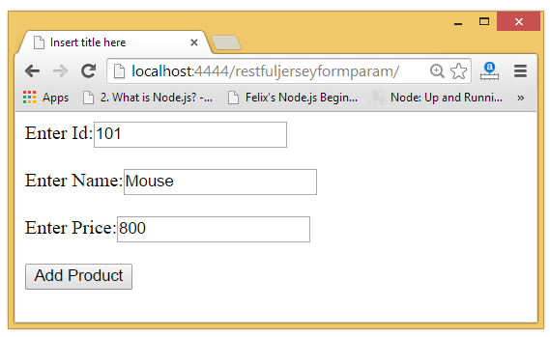  
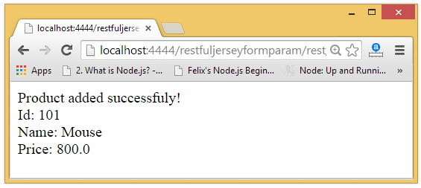

RESTful JAX-RS File Download Example

We can download text files, image files, pdf files, excel files in java by JAX-RS API. To do so we need to write few lines of code only. Here, we are using jersey implementation for developing JAX-RS file download examples.

You need to specify different content type to download different files. The @Produces annotation is used to specify the type of file content.

1. **@Produces("text/plain")**: for downloading text file.
2. **@Produces("image/png")**: for downloading png image file.
3. **@Produces("application/pdf")**: for downloading PDF file.
4. **@Produces("application/vnd.ms-excel")**: for downloading excel file.
5. **@Produces("application/msword")**: for downloading ms word file.

Questions…………………………..

### **14) What tools are used to test web services?**

* **SoapUI tool** for testing SOAP and RESTful web services
* **Poster** for firefox browser
* **Postman** extension for Chrome

### **15) What is the advantage of XML in web service?**

In Web service, an XML is used to tag the data, format the data.

### **16) What is the usage of WSDL in a web service?**

WSDL is used in web service to describe the availability of service.

### **17) What is Interoperability in Web services?**

Web services facilitate various applications to communicate with each other and share data and services among themselves. Other applications can also use the web services. For example, a VB or .NET application can communicate with a Java web services and vice versa. Web services are used to make the application platform and technology independent.

### **18) Explain the loosely coupled architecture of web services.**

A consumer of a web service is not tied to that web service directly. The web service interface can change over time without compromising the client's ability to interact with the service. A tightly coupled system implies that the client and server logic are closely tied to one another, implying that if one interface changes, the other must be updated. Adopting a loosely coupled architecture tends to make software systems more manageable and facilitates simpler integration between different systems.

### **19) What are the advantages of having XML based Web services?**

Using XML eliminates any networking, operating system, or platform binding. So Web Services based applications are highly interoperable application at their core level.